LAB ASSIGNMENT V : HEURISTIC EVALUATION
SYSTEM EVALUATED : | PropNest (Digital Real Estate Platform)
EVALUATION SCOPE : | Wireframe UI / Search, Filtering & Transparency Flow
EVALUATOR / USER PERSONAS : | Evaluated against Aditya & Priya Joshi, Vikram Patil, Rohan Mehta, Ananya Sharma, Karan Shah

PART I : HEURISTIC EVALUATION BASED ON NIELSEN'S 10 GENERAL PRINCIPLES FOR INTERACTION DESIGN–––
(Scoring Scale: 0 is lowest / severe violation, 10 is highest compliance / excellent usability)
S.No. | Heuristic Evaluation Parameter | Mention Violation if any | Severity (0-10) | Ways to Improve
1 | User Control  (Interface allows user to perceive they are in control) | Main hero search (City, Locality, Budget, Buy/Rent) provides strong core control. However, explicit quick-sorting controls (e.g., Sort by Price, Possession Date, Safety Rating) are not directly exposed on the primary hero bar before executing search. | 9 | Integrate a quick-sort pill toggle (e.g. 'Sort by: Price | Possession | Safety') next to the main search execution button.
2 | Human Limitations  (Interface will not overload cognitive, auditory and motor skills) | Clean 'calm search' design effectively reduces cognitive overload present in Housing.com (banner ads) and SquareYards (busy multi-tool layout). Displaying price, BHK, locality, safety index, and RERA status simultaneously requires modest visual scanning. | 9 | Maintain generous card padding, structured typography hierarchy, and subtle badge shading so 'all-in' totals remain scannable.
3 | Accommodation  (Interface fits how each user group works & thinks - Personas) | No major violation. Directly accommodates target user persona frustrations:  • Aditya & Priya (Newlyweds): All-in transparent total.  • Vikram Patil (Family): Safety Index & RERA check.  • Rohan Mehta (Relocating Engineer): Direct site visit schedule & side-by-side compare.  • Ananya Sharma (Student): Locality safety badge (4.8/5).  • Karan Shah (Investor): Price/sq.ft & timeline metrics. | 10 | Introduce persona-based quick filters (e.g., 'Family-Safe Homes', 'Student Accommodation', 'High ROI Investment').
4 | Linguistic Clarity  (Interface communicates as efficiently as possible) | Slogan 'Find a home with nothing hidden' and labels ('100% RERA verified', 'Zero hidden charges', 'Resident safety index') avoid legal jargon (unlike MahaRERA). First-time buyers may benefit from explicit clarity on what 'all-in' encompasses. | 9 | Add an info-icon tooltip beside 'all-in price' on property cards explaining that it includes Base Price + Stamp Duty (7%) + Maintenance.
5 | Aesthetic Integrity  (Interface has attractive & appropriate design) | Warm neutral tones, spacious layout, clear badge contrast, and crisp property images present a reassuring, premium, and trustworthy brand image. | 10 | Ensure high-contrast mode (accessible via left UI accessibility drawer) maintains visual elegance while adhering to WCAG AAA contrast.
6 | Simplicity  (Interface has a simple design) | Focused 3-input hero search bar (City, Locality, Budget) eliminates unnecessary clutter and search friction. | 9 | Keep secondary filter options progressively disclosed inside an 'Advanced Filters' drawer so the primary screen remains minimal.
7 | Predictability  (Interface behaves so user accurately predicts next action) | Standard 'Search', 'View details', and 'Compare' buttons function intuitively. Clicking 'Compare' adds the property to the comparison tray. | 9 | Add an immediate animated badge counter (+1, +2) on the floating 'Compare' widget to confirm addition instantly.
8 | Accuracy  (Interface is free from errors) | Pre-calculated 'All-in total price' (Base + Stamp Duty + Maintenance) prevents manual user calculation errors. | 9 | Implement real-time locality auto-complete validation to prevent typos or empty query submissions.
9 | Technical Clarity  (Interface has highest possible fidelity) | Clean layout with built-in accessibility controls (Desktop/Mobile toggle, Hi-Fi/Lo-Fi, Larger Text, High Contrast) in left control drawer. | 10 | Optimize image rendering and use responsive lazy-loading for property visual cards.
10 | Fulfillment  (Interface provides a satisfying user experience) | Directly fulfills user emotional needs identified in research empathy maps (relieving anxiety regarding hidden fees and fraudulent listings). | 9 | Provide a one-click 'Export PDF Summary' or shareable link for family decision-making.
11 | Consistency  (Interface is consistent) | Property cards follow uniform layout (Thumbnail, Title, BHK, Locality, Possession Year, All-in Price, Action Buttons) across search results. | 10 | Enforce fixed card container heights across all grid items to prevent card misalignment if property titles wrap to two lines.
12 | User Support  (Interface provides additional assistance as needed) | Accessibility tools drawer provides solid support. However, live advisor or chat assistance is not directly visible on the hero screen. | 8 | Add a floating 'Chat with PropNest Advisor' widget in the bottom-right corner for real-time guidance.
13 | Precision  (Interface allows users to perform a task exactly) | Exact budget ranges (₹75L - ₹1.2Cr) and precise locality typing enable exact search scope. | 9 | Allow direct numeric input for custom min/max budget bounds in addition to dropdown ranges.
14 | Forgiveness  (Interface makes action recoverable) | Easy parameter toggling, Buy/Rent tab switching, and property deselect capabilities support easy recovery. | 9 | Include an explicit 'Reset Search Criteria' button next to the search button.
15 | Responsiveness  (Interface informs users about results of actions & status) | Search bar provides clear real-time match feedback (e.g., '24 verified matches'). | 9 | Add smooth skeleton loading states during filter updates so users know the system is fetching updated results.
TOTAL SCORE: 137 / 150 (Average Compliance & Usability Rating: 9.13 / 10)
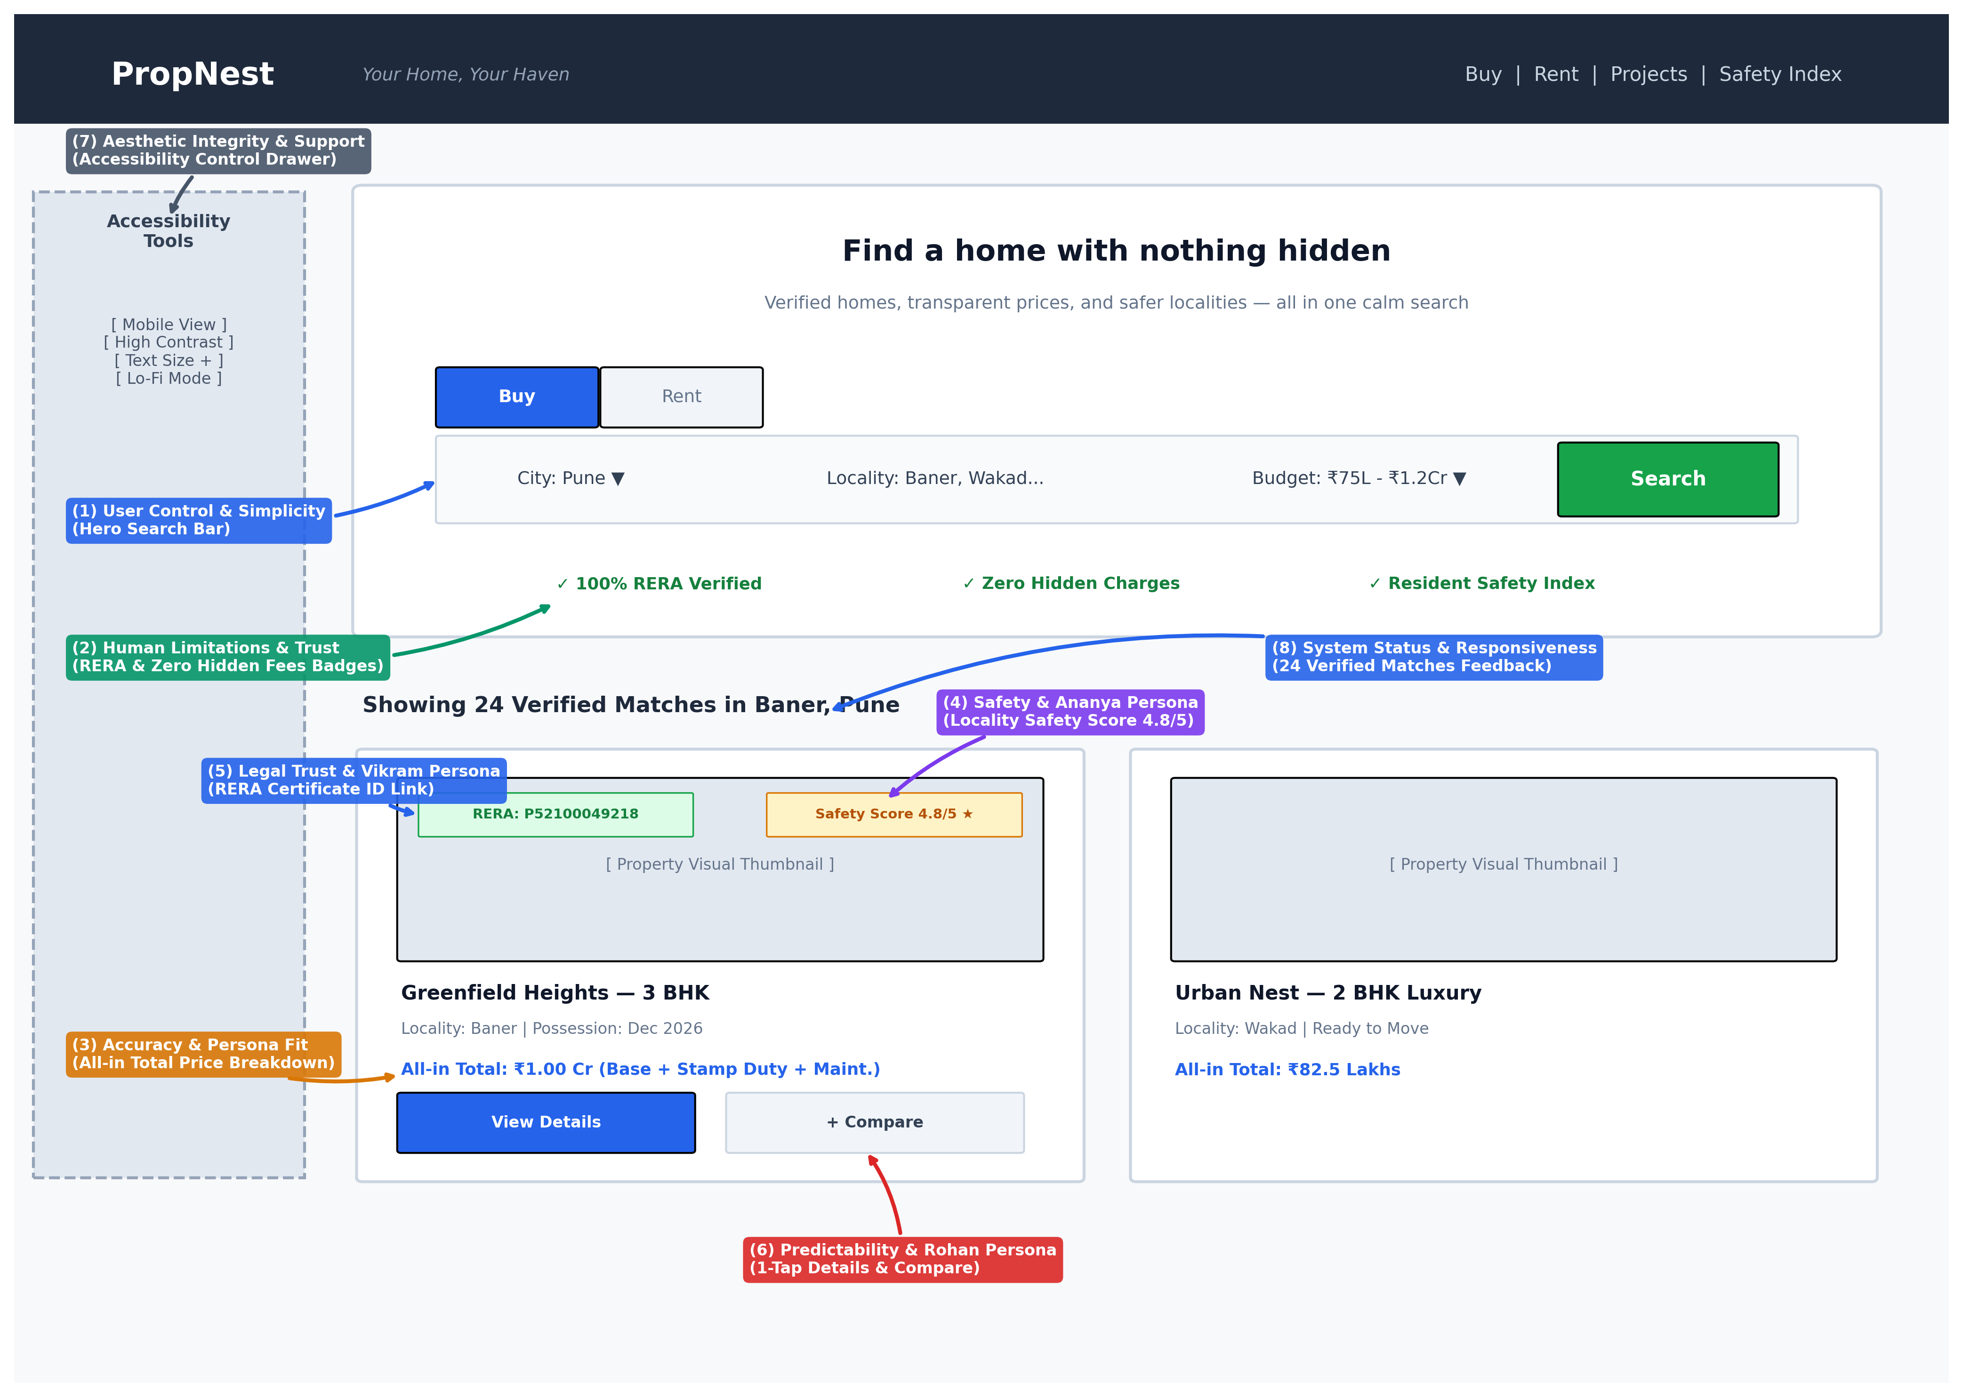

PART II : LIST OUT ANY OTHER POINTS THAT YOU MAY HAVE MISSED OUT (Other than Nielsen's Principles)
S.NO | OBSERVATIONS | COMMENTS
1 | Locality Safety & Resident Index Integration  (PropNest features a dedicated 'Resident Safety Index' badge e.g., Safety 4.8/5 with street lighting and transit metrics). | Directly addresses critical safety concerns identified in user research for student and family personas (Ananya Sharma & Vikram Patil). Fills a key gap missed by Housing.com and Bayut, enhancing decision reassurance.
2 | Transparent 'All-in' Total Pricing Breakdown  (Displays all-inclusive pricing upfront e.g., ₹1.00Cr all-in, breaking down base price, stamp duty, and maintenance). | Eliminates unexpected financial surprises and hidden charges, directly solving the primary pain point highlighted in competitive benchmarking against Housing.com.
3 | Integrated Legal Verification (RERA Certificate Check)  (Embeds 100% RERA verification with inline certificate ID links e.g., P52100049218). | Streamlines institutional trust and legal validation without forcing users to navigate complex, form-heavy government portals like MahaRERA.
Students Evaluation Team : PropNest / UI UX Research Panel

